# Level Design

The level runs a mod script which is in the config/AccidentallyCircumstantialEvents folder in the server. The script is explained below

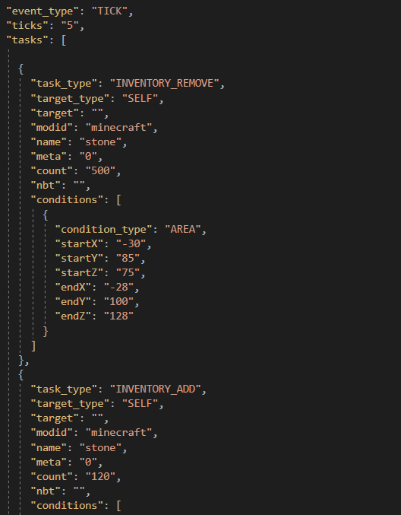

The inventory add and inventory remove command runs every 5 ticks of the game (20 ticks = 1 second). These commands are only activated when the player reaches a certain location in the map. This was done to control the number of blocks that each player needs to complete the puzzle.

Various identifiers in the functions are: -

* Task_type – Describes the type of task it should perform
* Target_type – SELF means that it will target each player that is in the area
* Modid – Specifies the blocks location in Minecraft, in vanilla Minecraft all blocks have the modid of Minecraft
* Name – The name of the block that we want to give/take from the player
* Meta – If the block has any attributes that are special
* Count – The quantity of blocks that we need to manipulate

The important thing to remember is to remove the inventory before adding as if the player stays in the area, they can get infinite blocks. I also set the remove count to 500 to ensure that the inventory is always reset to zero when we need it.

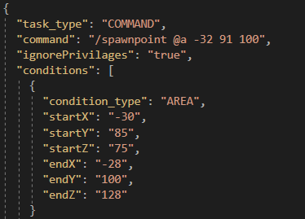

This command changes the spawn point of the player once they pass a certain area. This means that once the player has cleared the previous puzzle, even on death, they will not respawn at the very start

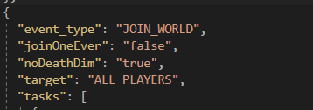

This event type only executes once for every player once they join the server

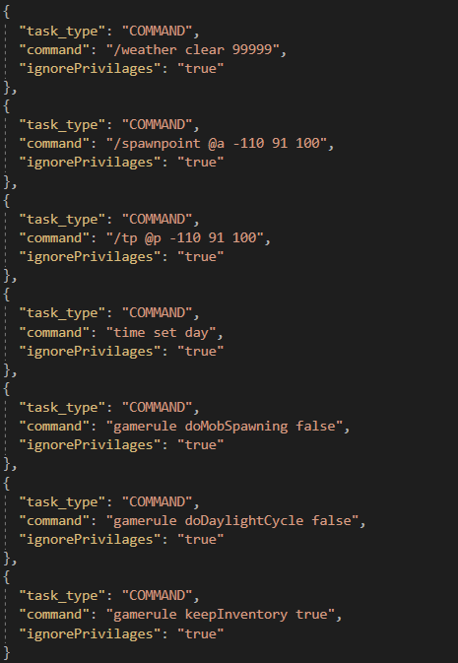

These are all commands that run when the player joins the server. Most of these commands are to provide ease of life and consistency to the server, such as, keeping inventory on death, not changing time of day, keeping the weather clear and not spawning mobs of monsters in the world. The ignore privileges makes sure the commands are run for each player regardless of their permission level in the server.

The walking speed in Minecraft is 4.3 blocks per second and sprinting speed is 5.6 blocks per second. The terrain the middle of the puzzles was kept to 60 blocks while keeping this in mind.

I designed the puzzles to take more time as the player progresses through the level

* Puzzle 1 – Total expected time 3 mins
* Puzzle 2 – Total expected time 5 mins
* Puzzle 3 – Total expected time 7 mins

# Server set up

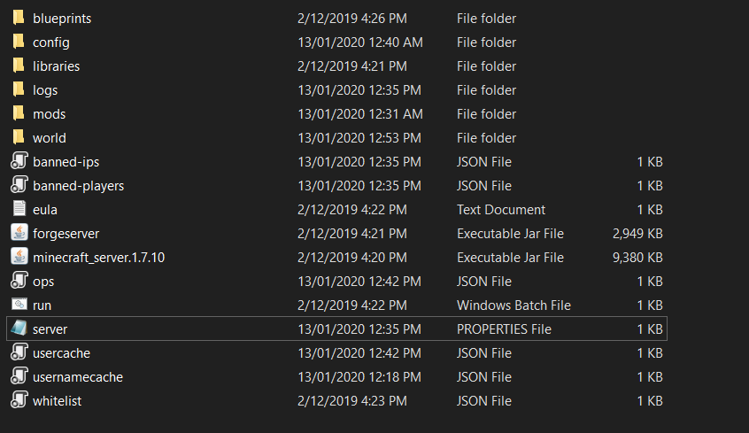

The server folder setup should look something like this. The world folder is where the level data is stored, one server can only hold one level at one time. The EULA must be true at all times otherwise the server will not run.



The executable jar file must also be names forgeserver for the startup script to run properly

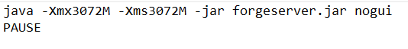

(The 3072M means a 3gbs allowance to the server, which should be enough for this project)

The server properties can also be changed from the server.txt file, I have changed some of the important ones like disabling monsters, no PvP combat, no flight allowed, etc.

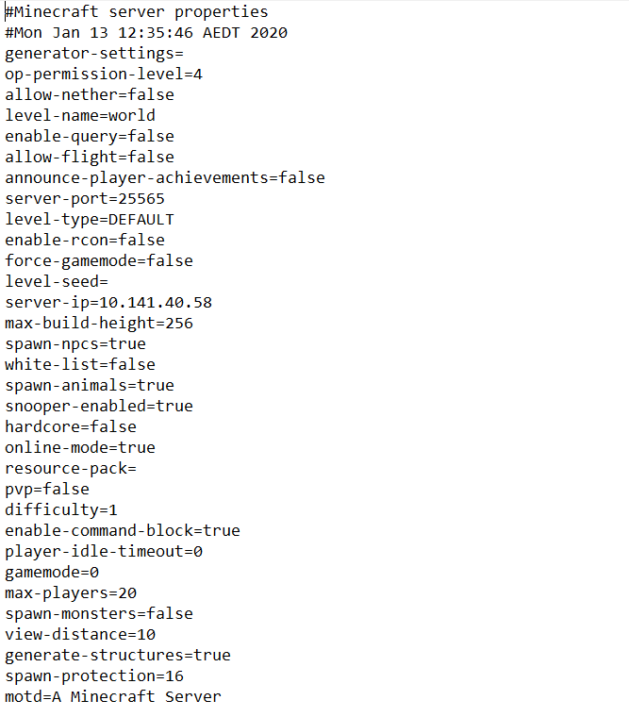

The most important of these is the server IP address that must be updated before the server runs, as each computer will have a different IP address, and the servers IP is the same as the machine its running on.

In the ops file in the server, we can allocate permission rights to players. Currently DeakinHIve1 has been given full rights (level 4).

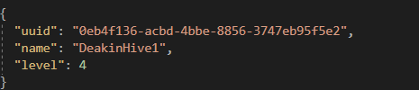

The UUID of each email is different can found be extracted using this link. <https://mcuuid.net/>

In the logs folder, we can find the logs for the events that happen in the server, including the text chat

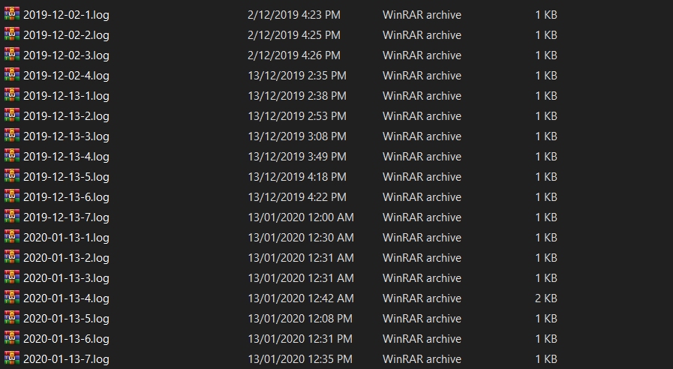

Simply browse the logs of the server date and time you want. The last log will always be in a file called latest.txt in the logs folder.

# USB Set up

Each USB has 3 folders which are appropriately named.

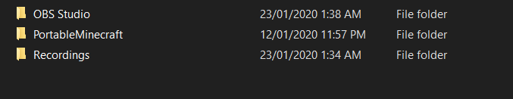

OBS Studio is the recording software for the USB, PortableMinecraft runs a portable version of Minecraft and Recordings store the recordings.

Both OBS Studio and Minecraft have been tested to run for all USBs. To run Minecraft, simply go into the Minecraft folder and double click the run script. You also have to log in as its not possible to store log in data on USB.

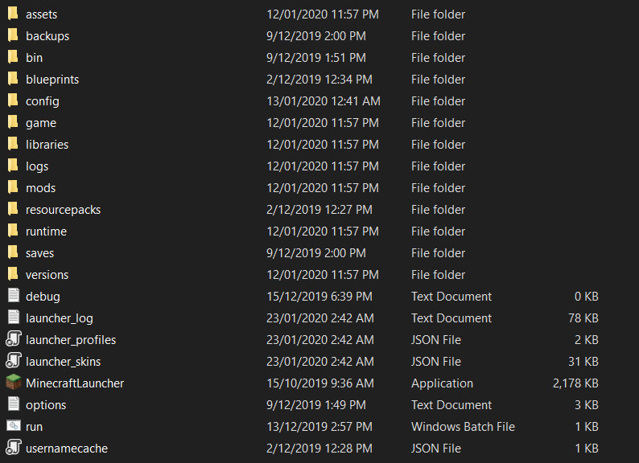

The run script works in a very simple way, where I tell it to start the program and tell it which folder path its working directory for all data storage is.



To ensure full compatibility of the mods with the server, the same mods should also be placed in the config folder of each USB (This has already been done for the mod I’m using). I’ve also changed the skin for all emails (Except DeakinHive19,20,21 – for whom Minecraft has not yet been purchased at the time I checked)

To run OSB studio, simple go into OSB studio folder and double click on the program icon

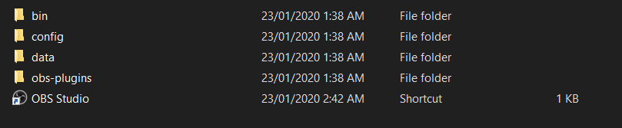

Once you’ve run the OSB studio, I’ve saved a profile where the screen capture is already set up and it automatically finds the recording folder to save those recordings. All the person has to do is the start and stop the recording in the program itself.

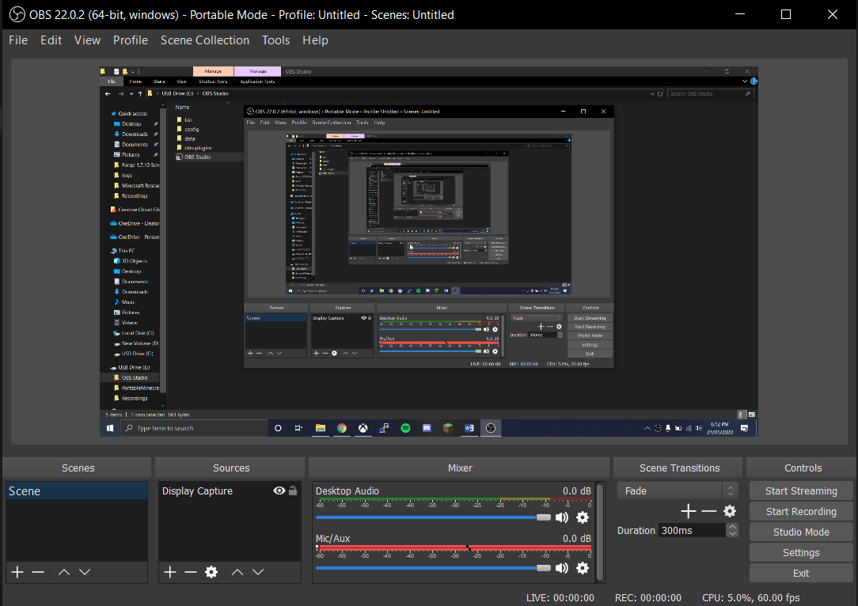

I’ve set up the OBS Studio to run in portable mode, and as such it will run on all computers even if the USBs drive letter is changed. Windows often puts random letters for drives and as such, putting a fixed path never works.

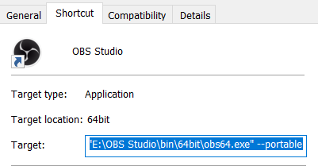

I’ve also set the recording path dynamically so that it is also irrespective of the drives letter.



# Video Tutorial

I’ve uploaded the tutorial video on YouTube under the [DeakinHive1@gmail.com](mailto:DeakinHive1@gmail.com) and named it Minecraft tutorial Video. The link for the video is <https://youtu.be/-wMVJaLZcDE>